CS 255 Business Requirements Document Template

Complete this template by replacing the bracketed text with the relevant information.

This template lays out all the different sections that you need to complete for Project One. Each section has guiding questions to prompt your thinking. These questions are meant to guide your initial responses to each area. You are encouraged to go beyond these questions using what you have learned in your readings. You will need to continually reference the interview transcript as you work to make sure that you are addressing your client’s needs. There is no required length for the final document. Instead, the goal is to complete each section based on your client’s needs.

Tip: You should respond in a bulleted list for each section. This will make your thoughts easier to reference when you move into the design phase for Project Two. One starter bullet has been provided for you in each section, but you will need to add more.

System Components and Design

Purpose
What is the purpose of this project? Who is the client and what do they want their system to be able to do?
• Create an online system for DriverPass to train students for DMV driving tests.
• Combine online courses, practice exams, and on-road lesson scheduling in one place.
• Allow the owner and staff to access data from any computer or phone with an internet connection.
• Let users download certain reports to Excel to work with offline.

System Background
What does DriverPass want the system to do? What is the problem they want to fix? What are the different components needed for this system?

• Current problem: many people fail the DMV test due to poor training resources.
• The solution: a cloud-based web application providing classes, tests, scheduling, and reporting.
• Key components: web portal, database, lesson scheduling, student progress tracking, reporting tools, and DMV update integration.
• Roles: owner, IT officer, secretary, drivers, and students—each needs different permissions.

Objectives and Goals
What should this system be able to do when it is completed? What measurable tasks need to be included in the system design to achieve this?
• Let students register, purchase packages, and book two-hour lessons.
• Prevent double-booking of drivers or cars.
• Track student progress on practice tests (test name, time, score, status).
• Record instructor notes with start hour, end hour, and comments.
• Maintain an audit trail showing who created, changed, or canceled any reservation.
• Notify staff when DMV rules or question banks change.
• Export reports to Excel for analysis.

Requirements

Nonfunctional Requirements
In this section, you will detail the different nonfunctional requirements for the DriverPass system. You will need to think about the different things that the system needs to function properly.

Performance Requirements
What environments (web-based, application, etc.) does this system need to run in? How fast should the system run? How often should the system be updated?

• Run as a web-based cloud system accessible by browsers and mobile devices.
• Common actions (login, scheduling) should be loaded within a few seconds.
• The system should be available most of the time with scheduled maintenance when needed.

Platform Constraints
What platforms (Windows, Unix, etc.) should the system run on? Does the back end require any tools, such as a database, to support this application?
• Works on modern browsers (Chrome, Edge, Safari, Firefox).
• Back-end uses a cloud database for student, driver, and schedule data.
• Connects to the DMV feed for rule updates and exports CSV/XLSX files.

Accuracy and Precision
How will you distinguish between different users? Is the input case-sensitive? When should the system inform the admin of a problem?
• Each user has a unique, verified login.
• The system distinguishes users by role (Owner, IT Admin, Secretary, Driver, Student).
• Validates input for addresses, phone numbers, and times.
• Prevents overlapping reservations for the same car or driver.
• Alerts admin when login attempts fail or system errors occur.

Adaptability
Can you make changes to the user (add/remove/modify) without changing code? How will the system adapt to platform updates? What type of access does the IT admin need?
• IT Admin can add, remove, or modify users without changing code.
• Admin can disable packages temporarily.
• Designed to work through browser updates with no local install.

Security
What is required for the user to log in? How can you secure the connection or the data exchange between the client and the server? What should happen to the account if there is a “brute force” hacking attempt? What happens if the user forgets their password?
• Enforce secure HTTPS connections and strong passwords.
• Lock accounts after multiple failed login attempts.
• Allow password resets by secure email link.
• IT Admin can deactivate or reset any account.
• Protect payment data using a third-party processor; only keep limited details.

Functional Requirements
Using the information from the scenario, think about the different functions the system needs to provide. Each of your bullets should start with “The system shall . . .” For example, one functional requirement might be, “The system shall validate user credentials when logging in.”
• The system shall allow students to create accounts and log in securely.
• The system shall let students and the secretary schedule, modify, or cancel 2-hour lessons.
• The system shall prevent double-booking of drivers and cars.
• The system shall store and display practice-test progress, including test name, time taken, score, and status.
• The system shall record instructor lesson notes, including start hour, end hour, and comments.
• The system shall maintain a full audit log of all reservation actions, including who created, edited, or canceled them and when.
• The system shall allow automatic password resets for users who forget their credentials.
• The system shall let the IT Admin disable packages or accounts when needed.
• The system shall notify staff automatically when DMV updates arrive.
• The system shall enable data export of reports to CSV or XLSX files.

User Interface
What are the needs of the interface? Who are the different users for this interface? What will each user need to be able to do through the interface? How will the user interact with the interface (mobile, browser, etc.)?
- Student view: dashboard showing online-test progress and upcoming lessons; scheduling page; profile settings and password reset.
- Driver view: daily schedule and table for lesson notes (start/end time, comments).
- Secretary view: search and add students, book appointments by phone, send confirmations.
- Owner/IT Admin view: manage users, drivers, cars, and packages; view audit reports; toggle packages on/off.
- Platform: responsive browser-based interface on desktop and mobile.

Assumptions
What things were not specifically addressed in your design above? What assumptions are you making in your design about the users or the technology they have?
• DMV will supply a data feed or file for updates.
• Payment processing handled by a secure third-party service.
• Pickup and drop-off locations are the same unless policy changes later.
• System maintenance and backups are handled by the cloud provider.

Limitations
Any system you build will naturally have limitations. What limitations do you see in your system design? What limitations do you have as far as resources, time, budget, or technology?
• Users cannot edit data offline; they can only view or export it.
• DMV integration changes may require developer support.
• Only core features delivered in this release; future custom packages planned later.
• No dedicated mobile app yet; focus is on the responsive web app.

Gantt Chart
Please include a screenshot of the GANTT chart that you created with Lucidchart. Be sure to check that it meets the plan described by the characters in the interview.

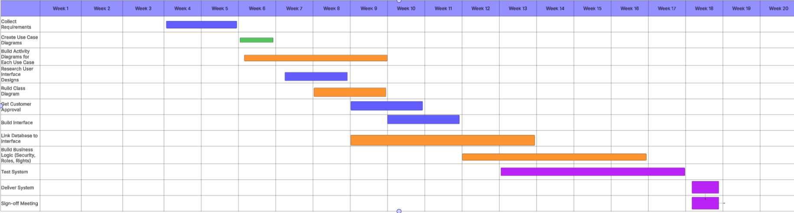
• Collect Requirements → Jan 22 – Feb 4
• Create Use Case Diagrams → Feb 11 – Feb 18
• Build Activity Diagrams → Feb 15 – Mar 9
• Research UI Designs → Feb 27 – Mar 7
• Build Class Diagram → Mar 1 – Mar 9
• Customer Approval → Mar 10 – Mar 11
• Build Interface → Mar 12 – Mar 24
• Link DB to Interface → Mar 24 – Apr 3
• Build Business Logic → Apr 5 – Apr 27
• Test System → Apr 27 – May 7
• Deliver System → May 8 – May 9
• Sign-off Meeting → May 9 – May 10

